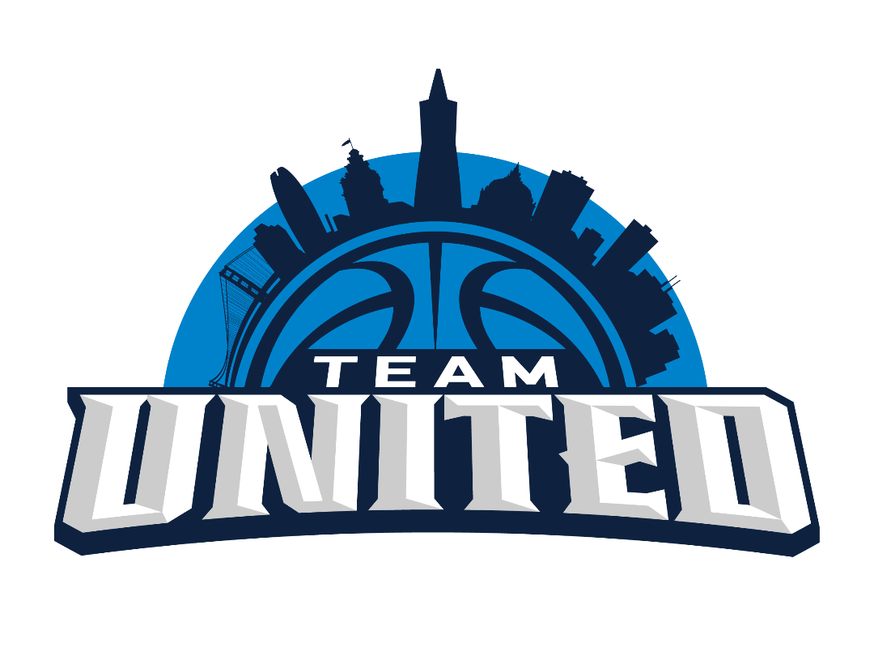

SPORTSMANSHIP
Any fan that is negative towards players, coaches or refs, will be asked to leave.
NO REFUNDS!

Any fan, coach or player who is making distracting noises during Free Throws will be asked to leave the gym.
NO EXCEPTIONS!
Please be respectful as this tournament is for the kids to play hard, learn and have fun.

